Templates for

Control Medi Multi and Control Medi Standard

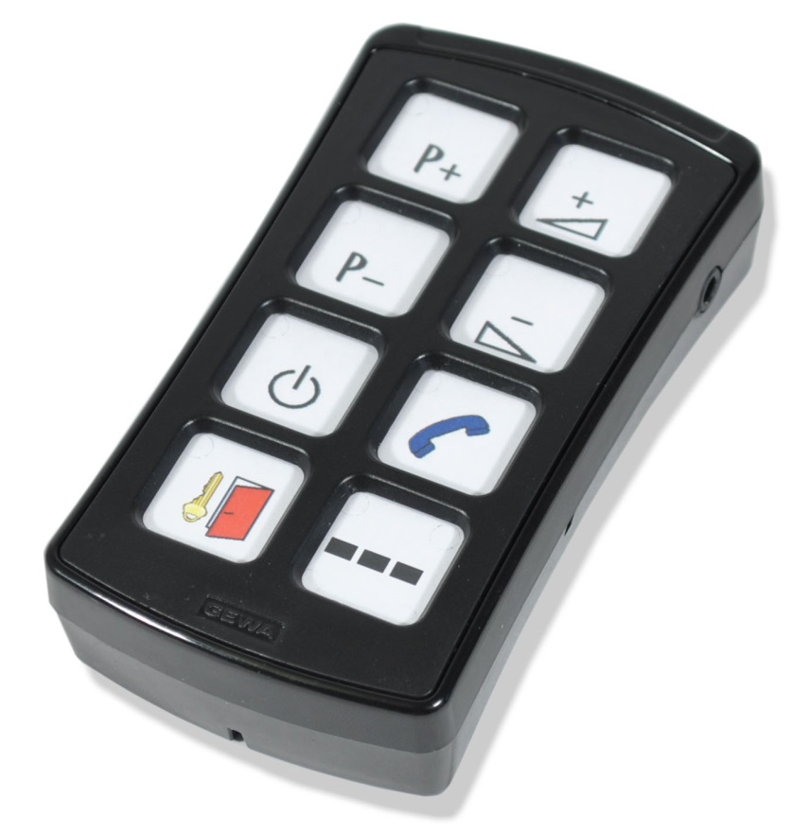

Templates

AAAA
BBBB
CCCC

!
AAAA
BBBB
CCCC

AAAA
BBBB
CCCC

AAAA
BBBB
CCCC

AAAA
BBBB
CCCC

1
2

4
3
AAAA
BBBB
CCCC

5
6

!

AAAAAA
AAAAAA
AAAAAA
AAAAAA
AAAAAA
AAAAAA
AAAAAA

AAAAAA












Make your own overlay!
Create your own text or use enclosed pictures. Following pages contains 400 pictures.

BED



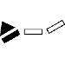
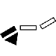









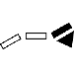
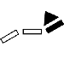

DVD


















































































HIFI












































NUMBERS























SYMBOLS

























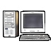



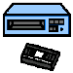
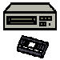



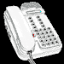
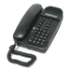
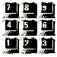
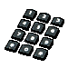

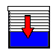
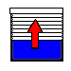





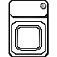

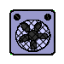









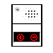





PICTOGRAM























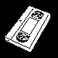


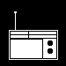





TELEPHONE
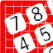















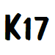



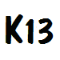
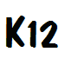























TV
















































VCR











Doc: Overlay Design Control Medi Multi_Standard , A4, Ver: A. Date: 2013-08-20.

Abilia AB, Kung Hans väg 3, Sollentuna, Box 92, 191 22 Sollentuna, Sweden
Phone +46 (0)8-594 694 00 | Fax +46 (0)8-594 694 19 | info@abilia.se | www.abilia.se

